MAY 2018

To Whom It May Concern:

**INTRODUCING BATHCO SOUTH AFRICA – the bath collection - ‘Bathco SA’**

Finally, a company that understands the need to be unique in the way we live…….

Bathco SA allows you to proudly express your individual creative visions by offering many new and exciting options not currently seen before in South Africa, as well as a full range of quality affordable designer Porcelain Sanitaryware.

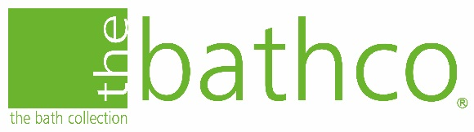Bath Collection S.L (Bathco) has been operational for over 43 years from its Santander Headquarters in the North of Spain.

The company has grown significantly, and now distributes to over 93 countries on all 5 continents, and is a leading player in the world-wide Sanitaryware market.

Bathco is a market leader in term of setting trends - this is evident in the latest basin design ranges launched over recent years that include - ***Natural Stone, Vintage & More, Titanic, Micro-cement, Wood, Gold & Silver and Swarovski.***

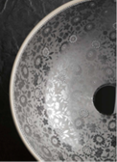In 2016/2017 Bathco received the coverted [A’Design,](https://competition.adesignaward.com/design.php?ID=53149) and a Red Dot Design Award.

What makes Bathco unique is its workshop [‘Atelier](http://atelier.thebathcollection.com/el-atelier/)’ that houses four full-time artists with the abilitiy to transform basins and tiles into amazing works of art. These artists draw their creativeness from their clients stories to bring exceptionally tailored centre pieces to the bathroom space.

Bathco are based in Spain, a country already world renowned for its high quality of workmanship within the Poreclain Sanitaryware industry.

This is supported by continuous certification, and audit cycles such as ISO9001:2015 and CE Approvals.

Bathco SA, a newly formed dedicated Sanitaryware company, operates from a flagship showroom in the heart of Fourways just off William Nicol.

This new company has been formed by the directors of two of the countries best Fireplace Companies - ***Cosy Heating and Morso Fireplaces*** - to take advantage of the clear synergy that exists between them and to continue the high levels of customer service and aftercare gained from over 20 years of retail lifestyle management.

Please take the time to look at the Bathco website for inspiration and to see what we can offer -www.thebathcollection.com

GROHE’s people have been regarded by their peers in the industry as Masters of Technology, because of their innovations, outstanding design and awardwinning fittings.

We have partnered with Grohe to be one of their flagship showroom in Gauteng – we will have a full display of Grohe faucets and bathroom accessories.

Bathco SA mission statement is to provide a world class creative experience to its customers that they can rely on time and time again. This will be achieved by leaving each customer in a far superior place after each interaction with Batchco SA than before.

We look forward to meeting you, your clients and turning dreams into reality.

Yours sincerely,



Sales Director | Miguel Tavares

Cell: 083 383 7848

Email: miguel@bathcosa.co.za

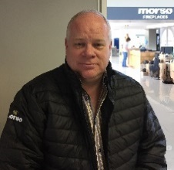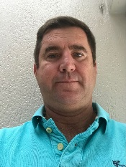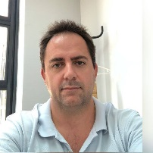Meet the team: -

Miguel Tavares Bruce Gould Andrew Balding

Sales Director Joint MD Joint MD